集团审计的组成部分重要性
2008-12-1

Determining overall group materiality and materiality levels for individual components is becoming more of a hot-button issue as the number and complexity of large and international group audits increases. Auditing standards and other professional materials offer little practical guidance on the topic.

随着大型国际集团审计的数量和复杂性的增加，确定整体集团重要性和组成部分重要性成为一个热点问题。审计准则和其他专业资料几乎没有提供关于该主题的实用指导。

Internal and peer reviews and regulatory inspections have revealed a variety of approaches in this area. In some instances, reviews have discovered potentially troubling practices. Our conversations with regulators and practitioners indicate an intense and growing interest in the development of conceptually sound guidance. This article outlines a practical approach that group engagement partners can consider in establishing or evaluating component materiality.

内部和同行审查以及监管检查揭示了该领域的各种方法。在某些情况下，审查发现了潜在的麻烦做法。我们与监管机构和从业者的对话表明，人们对制定合理的指南有着浓厚且不断增长的兴趣。本文概述了项目组在确定组成部分重要性时可以考虑的实用方法。

GUIDANCE IN THE AUDITING STANDARDS
A group audit is performed on an entity with multiple locations or components, such as subsidiaries, with separately audited financial information included in consolidated or group financial statements. To properly plan the nature and extent of audit procedures for the group audit, the group engagement partner, who is the lead auditor for the consolidated entity, must determine group overall materiality and establish or approve appropriate materiality levels for the individual components. The component materiality level helps guide the component auditors in planning and performing audit procedures to achieve the desired level of audit risk at each component such that the group auditor achieves the desired level of group overall audit risk on the consolidated financial statements.

审计准则指南
集团审计是对拥有多个组成部分（例如子公司）进行的，其单独审计的财务信息包含在合并或集团财务报表中。为了正确规划集团审计的审计程序的性质和范围，作为合并实体的首席审计师的集团项目合伙人必须确定集团的整体重要性，并为各个组成部分确定适当的重要性。组成部分重要性有助于指导组成部分审计师规划和执行审计程序，以在每个组成部分实现期望的审计风险水平，从而使集团审计师在合并财务报表上实现期望的集团整体审计风险水平。

U.S. auditing standards (AU section 312 and PCAOB’s Auditing Standard no. 5, paragraphs B10–B16 of Appendix B) provide a list of factors to consider in determining the extent of testing on a multicomponent audit. However, these standards don’t provide specific practical guidance on establishing componentlevel planning materiality, one of the principal factors used to determine the extent of testing.

美国审计准则（AU 第 312 条和 PCAOB 审计标准第 5 条，附录 B 的 B10-B16 段）提供了在确定组成部分审计范围时要考虑的因素列表。然而，这些准则没有提供关于如何确定组成部分重要性的具体实践指南。

The International Auditing and Assurance Standards Board (IAASB) recently released a revised and redrafted International Standard on Auditing (ISA) 600, Special Considerations—Audits of Group Financial Statements (Including the Work of Component Auditors), to provide additional guidance to group engagement partners. Paragraphs 21–23 and A42–A46 of ISA 600 provide guidance to help inform group engagement partner materiality decisions. Paragraph A43 provides the following guidelines regarding component materiality:

国际审计与鉴证准则委员会 (IAASB) 最近发布了修订和重新起草的国际审计准则 (ISA) 600，特别注意事项——集团财务报表的审计（包括组成部分审计师的工作），ISA 600 的第 21-23 段和 A42-A46 提供了指导，以帮助集团项目组确定重要性。第 A43 段提供了以下有关组成部分重要性的指南：

1、To reduce the risk that the aggregate of detected and undetected misstatements in the group financial statements exceeds the materiality level for the group financial statements as a whole, the component materiality level is set lower than the group materiality level.

1、为将未更正和未发现错报的汇总数超过集团财务报表整体的重要性的可能性降至适当的低水平，需要将组成部分重要性设定为低于集团财务报表整体的重要性。

2、Different materiality levels may be established for different components.
2、针对不同的组成部分确定的重要性可能有所不同。

3、The component materiality level need not be an arithmetical portion of the group materiality level and, consequently, the aggregate of the component materiality levels may exceed the group materiality level.

3、在确定组成部分重要性时，无需采用将集团财务报表整体重要性按比例分配的方式，因此，对不同组成部分确定的重要性的汇总数，有可能高于集团财务报表整体重要性。

Using the following examples, we hope to provide additional practical guidance to help group engagement partners navigate these guidelines

使用以下示例，我们希望提供进一步的实用指南，以帮助项目组浏览这些指南

AGGREGATE COMPONENT MATERIALITY
Aggregate component materiality is the sum of the individual component materiality amounts. ISA 600 implies two extreme endpoints for the measure of aggregate component materiality, one of which would generally be considered unnecessarily conservative and the other overly aggressive. Exhibit 1 illustrates the two extremes for an example company.

组成部分重要性总额
组成部分重要性总额是单个成分重要性的总和。 ISA 600 表明了衡量组成部分重要性合计数的两个极端，其中一个通常被认为是太保守，而另一个则过于激进。图表 1 说明了两个极端。
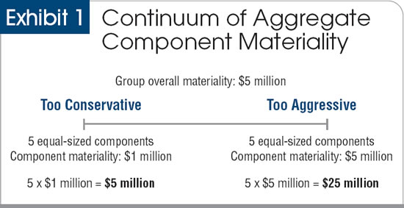

On the conservative extreme of the continuum, the group engagement partner could allocate an arithmetical portion of group overall materiality to each component, in which case aggregate component materiality is equal to group overall materiality. For example, given a group overall materiality of $5 million, $1 million is allocated to each of five equal-sized components.

在极端保守的情况下，集团项目组可以将集团整体重要性的加权平均分配给每个组成部分，在这种情况下，组成部分重要性总额等于集团整体重要性。例如，假设一个集团的整体重要性为 500 万美元，则每个同等规模的组成部分分配100万美元。

On the aggressive end of the continuum, the group engagement partner could set materiality for each component at nearly the group overall materiality figure, resulting in an aggregate component materiality that far exceeds group overall materiality. For example, given a group overall materiality of $5 million, approximately $5 million is allocated to each of five equal-sized components.

在极端激进的情况下，集团项目组可以将每个组成部分的重要性设置为接近集团整体重要性，从而导致组成部分重要性总额远远超过集团整体重要性。例如，假设一个集团的整体重要性为 500 万美元，每个同等规模的组成部分大约分配500 万美元。

Allocating full group materiality to each component results in an unacceptably high risk of audit failure. To illustrate this, assume that the desired audit risk at each component is 5%. Since each component is allocated the full amount of group overall materiality, the risk of an undetected material misstatement at the group level is the likelihood that any one of the five components has an undetected material misstatement, which is about 23% (1 – (0.95)5). Note that aggregate component materiality can exceed group overall materiality for many of the same reasons that the aggregate of tolerable misstatement allocated to account balances can exceed overall materiality in a financial statement audit.

将整个集团的重要性分配给每个组成部分会导致审计失败的风险高得令人无法接受。为了说明这一点，假设每个组成部分的期望审计风险为 5%。由于每个组成部分都分配了全部的集团整体重要性，因此在集团层面未发现重大错报的风险是五个组成部分中任何一个出现未发现重大错报的可能性，约为 23% (1 – (0.95 )5).请注意，由于许多相同的原因，在财务报表审计中，分配给账户余额的可容忍错报的合计可能超过整体重要性，因此组成部分重要性合计可能超过集团整体重要性。

Conversely, allocating an arithmetic portion—a simple proportion—of group overall materiality would generally result in over-auditing because the achieved audit risk at the group level would be extremely low.

相反，通过加权平均分配集团重要性通常会导致过度审计，因为在集团层面实现的审计风险将极低。

While ISA 600 implies it is appropriate for group engagement partners to avoid the extreme endpoints of the continuum shown in Exhibit 1, it does not spell out how to determine a reasonable and justifiable level of aggregate component materiality between these two extremes.

虽然 ISA 600 说明团体项目组避免出现图 1 所示极端激进是适当的，但它并未说明如何合理地确定这两个极端之间的组成部分重要性总额。

MAXIMUM AGGREGATE COMPONENT MATERIALITY
Aggregate component materiality can be expressed as a multiple of group overall materiality. Using Exhibit 1, the conservative extreme indicates a multiple of 1 ($5 million ÷ $5 million = 1), whereas the aggressive extreme indicates a multiple of 5 ($25 million ÷ $5 million = 5). We developed a probabilistic model to generate multiples that can be applied to calculate a reasonable upper bound for aggregate component materiality based on the group overall materiality level and the number of components (for a complete description of the model, click here).

最大组成部分重要性总额
组成部分重要性总额可以表示为集团整体重要性的倍数。使用图表 1，保守极端表示 1 的倍数（500 万美元 ÷ 500 万美元 = 1），而激进极端表示 5 的倍数（2500 万美元 ÷ 500 万美元 = 5）。我们开发了一个概率模型来生成倍数，该模型可用于根据集团整体重要性水平和组成部分数量计算组成部分重要性总额的合理上限（有关模型的完整描述，请单击此处）。

The multiples derived from the model to determine the maximum aggregate component materiality (MACM) are presented in Exhibit 2. We refer to these MACM multiples as benchmark multiples.

表 2 显示了从模型中得出的用于确定最大组成部分重要性 (MACM) 的倍数。我们将这些 MACM 倍数称为基准倍数。

Our set of benchmark multiples assumes that the group engagement partner has used appropriate professional judgment to determine the number of significant components to which MACM will be allocated, including removing any insignificant components that are immaterial in aggregate and that are of sufficiently low risk (in accordance with ISA 600, paragraphs A50–A53).

我们的基准乘数集假设集团项目合伙人已使用适当的专业判断来确定， MACM 将分配给的重要组成部分的数量，包括去除任何总体上不重要且风险足够低的不重要组成部分（根据与 ISA 600，第 A50–A53 段）。

To determine the upper bound suggested by the model, the group engagement partner multiplies group overall materiality by the appropriate benchmark multiple from the table and then uses the calculated MACM as a reference point in establishing component materiality levels or evaluating the component materiality levels proposed by component auditors.

为确定模型建议的上限，集团合伙人将集团整体重要性乘以表中适当的基准倍数，然后使用计算出的 MACM 作为参考点来确定组成部分重要性水平或评估组成部分会计师确定的重要性是否合理。

Returning to our example of a group audit with five components, applying the benchmark multiple of 2.5 to group overall materiality of $5 million yields an MACM of $12.5 million—a reasonable upper bound available for allocation to the components. See the sidebar, “Approaches for Allocating MACM,” for additional examples using the benchmark multiples to calculate MACM.

回到我们的包含五个组成部分的集团审计示例，应用 2.5 的基准倍数对 500 万美元的总体重要性进行分组，得出 1250 万美元的 MACM——可用于分配给组成部分的合理上限。有关使用基准倍数计算 MACM 的更多示例，请参阅边栏“分配 MACM 的方法”。

It is important to note that in evaluating audit results, the aggregate of known and projected misstatements from all components cannot exceed group overall materiality. Thus, even though the total amount of materiality allocated to the components ($12.5 million in our example) can exceed group overall materiality ($5 million in our example), evaluation of the aggregated known and projected audit differences for the consolidated entity is conducted using group overall materiality.

值得注意的是，在评估审计结果时，所有组成部分的已知和预计错报的总和不能超过集团整体重要性。因此，即使分配给组成部分重要性总额（在我们的示例中为 1250 万美元）可能超过集团整体重要性（在我们的示例中为 500 万美元），对合并实体的已知和预计审计差异汇总的评估是使用集团进行的整体重要性。

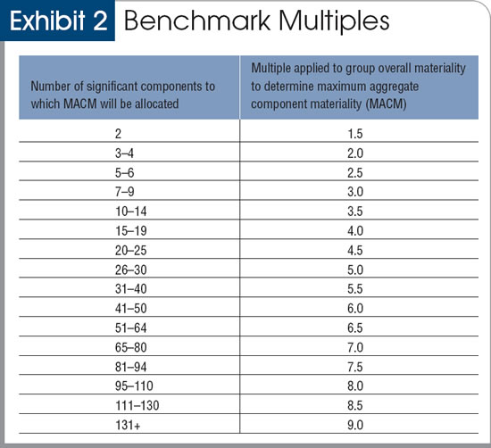
ADDITIONAL GUIDELINES FOR ESTABLISHING COMPONENT MATERIALITY
Now that we have determined a reasonable level of aggregate component materiality, the question becomes how to allocate this amount to components. In practice, it’s common for the component materiality levels to vary due to differing component sizes, statutory audit requirements, risk characteristics and country-specific guidelines. The group engagement partner allocates the MACM to the significant components using either proportional or weighted allocation techniques.

确定组成部分重要性的附加指南
既然我们已经确定了合计组成部分重要性的合理水平，问题就变成了如何将这个数量分配给组成部分。在实践中，由于不同的组成部分规模、法定审计要求、风险特征和特定国家/地区的指南，组成部分重要性水平通常会有所不同。集团项目合伙人使用比例或加权分配技术将 MACM 分配给重要组成部分。

An example of a weighted allocation technique is to take the square root of a component’s revenues and divide it by the sum of the square roots of each component’s revenues. The result is multiplied by MACM to determine materiality for that component.

加权分配技术的一个例子是取一个组成部分收入的平方根，然后除以每个组成部分收入的平方根之和。结果乘以 MACM 以确定该组件的重要性。

The proportional or weighted allocation techniques provide group engagement partners with a preliminary allocation strictly based on size. The preliminary allocation is then adjusted as appropriate based on each component’s risk characteristics. The sidebar provides examples of how both of these allocation techniques can be used.

比例或加权分配技术为集团合伙人提供了严格基于规模的初步分配。然后根据每个组成部分的风险特征适当调整初步分配。边栏提供了如何使用这两种分配技术的示例。

When there are different-sized components or required limits on the amount of materiality that can be allocated to some components, as in statutory audits, the following guidelines help ensure that the allocation achieves the desired level of audit risk at the group level:

当有不同规模的组成部分或对可分配给某些组成部分的重要性数量要求限制时，如在法定审计中，以下指南有助于确保分配在集团层面达到所需的审计风险水平：

1、Each component should receive an allocation that is less than group overall materiality (see ISA 600, paragraph A43).

1、每个组成部分应获得低于集团整体重要性的分配（参见 ISA 600，第 A43 段）。

2、The aggregate component materiality for the largest components is generally kept within the benchmark multiple for that number of components. For example, if a group is composed of three large components and 35 relatively small components, the group engagement partner would not likely allocate more than two times group overall materiality in aggregate to the three large components, based on the suggested benchmark multiple associated with three components.

2、最大组成部分重要性通常保持在该组成部分数量的基准倍数内。例如，如果一个集团由三个大的组成部分和 35 个相对较小的组成部分组成，则根据与三个组成部分相关的建议基准倍数，集团合伙人可能不会将超过两倍的集团整体重要性分配给三个大组成部分。

While the approach we suggest will help inform the group engagement partner’s judgment, we stress that because of the complexity and subjectivity of the variables involved, no single “correct” or “optimal” solution is possible. Auditors should apply appropriate professional judgment and follow local standards when establishing the materiality allocation for each component.

虽然我们建议的方法将有助于告知团队合作伙伴的判断，但我们强调，由于所涉及变量的复杂性和主观性，不可能有单一的“正确”或“最佳”解决方案。在确定每个组成部分的重要性分配时，审计师应运用适当的专业判断并遵循当地标准。

Approaches for Allocating MACM

These examples allocate MACM to components based on revenues; other financial bases could also be used.

分配 MACM 的方法
这些示例根据收入将 MACM 分配给组成部分；也可以使用其他财务基础。
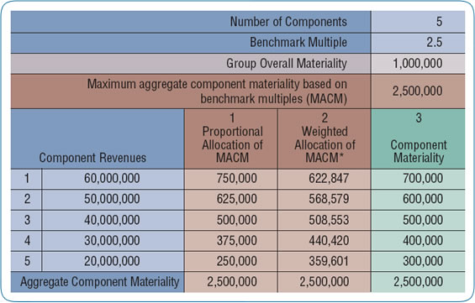
See “Illustrative weighted allocation formula for component materiality” below.

请参阅下面的“组成部分重要性的说明性加权分配公式”。

In this example, the group engagement partner multiplies the benchmark multiple of 2.5 (the multiple pertaining to five components—see Exhibit 2) by the group overall materiality of $1 million to determine the maximum aggregate component materiality, which is $2.5 million.

在此示例中，集团项目组将 2.5 的基准倍数（与五个组成部分相关的倍数 - 参见图表 2）乘以 100 万美元的集团整体重要性，以确定最大组成部分重要性总额，即 250 万美元。

For a simple proportional allocation of MACM (column 1), divide component revenues by total revenues, and multiply by MACM (for example to compute the allocation for component 5: 250,000 = 2,500,000 × 20,000,000 ÷ 200,000,000).

对于 MACM 的简单比例分配（第 1 列），将组成部分收入除以总收入，然后乘以 MACM（例如，计算组成部分 5 的分配：250,000 = 2,500,000 × 20,000,000 ÷ 200,000,000）。

For a weighted allocation of MACM (column 2), first take the square root of each component’s revenues and then take the sum of the square roots of all individual components’ revenues to compute the denominator for the weighted allocation formula (see illustrative weighted allocation formula on page 46). The square root of each component’s revenues is divided by the denominator and is then multiplied by MACM to determine the weighted allocation (for example, to compute component 5’s allocation: 359,601 = 2,500,000 × 4,472 ÷ (7,746 + 7,071 + 6,324 + 5,477 + 4,472).

对于 MACM 的加权分配（第 2 列），首先取每个组成部分收入的平方根，然后取所有单个组成部分收入的平方根之和来计算加权分配公式的分母（参见说明性加权分配公式第 46 页）。每个组成部分收入的平方根除以分母，然后乘以 MACM 以确定加权分配（例如，计算组件 5 的分配：359,601 = 2,500,000 × 4,472 ÷ (7,746 + 7,071 + 6,324 + 5,477 + 4,472) .

After considering the potential allocation approaches, the engagement partner established the final component materiality levels shown in column 3.

在考虑了潜在的分配方法之后，项目合伙人确定了第 3 栏中显示的最终组成部分重要性水平。

公司2

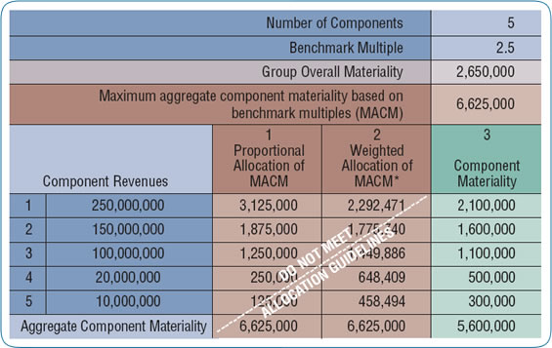

* See below, “Illustrative weighted allocation formula for component materiality.”
* 见下文“组成部分重要性的说明性加权分配公式”。

The significant size differences among the components of Company 2 preclude using strictly proportional or weighted allocations of the maximum aggregate component materiality (MACM). Under a simple proportional allocation approach (column 1), the largest component would have been allocated more than group overall materiality, which violates ISA 600. The allocation guidelines in the article also suggest that the aggregate allocation of materiality to the largest components not exceed the level indicated by the benchmark multiples. Thus, the three largest components should receive no more than two times group overall materiality (in this case, $5.3 million).

公司 2 的组成部分之间存在显着的规模差异，因此无法使用严格按比例或加权分配的最大组成部分重要性总额 (MACM)。在简单的比例分配方法（第 1 列）下，最大组成部分的分配将超过集团整体重要性，这违反了 ISA 600。文章中的分配指南，对最大组成部分重要性总分配不超过基准倍数所指示的水平。因此，三个最大的组成部分的重要性不应超过集团整体重要性的两倍（在本例中为 530 万美元）。

However, a proportional allocation of MACM would result in $6.25 million in aggregate being allocated to the three largest components, and the weighted allocation of MACM would result in $5,518,097 in aggregate being allocated to the three largest components. Therefore, considering the risk characteristics of the components, the materiality allocations shown in the component materiality column (3) would be appropriate.

然而，MACM 的比例分配将导致总计 625 万美元分配给三个最大的组成部分，MACM 的加权分配将导致总计 5,518,097 美元分配给三个最大的组成部分。因此，考虑到组成部分的风险特征，组成部分重要性栏（3）中显示的重要性分配将是合适的。

